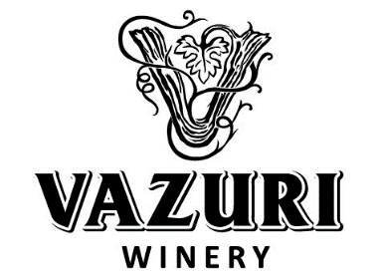
Price-list (EXW)
№ | Products | Color | Condition | Bottle |  | Year yield | Price  (USD)
 |  |  |  | Type of bottle | Volume Litters
1 | Kindzmarauli | Red | Semi sweet | Glass bottle | 0,75 | 2015 | 3.2
2 | Saperavi | Red | Dry | Glass bottle | 0,75 | 2015 | 2.4
3 | Mukuzani | Red | Dry | Glass bottle | 0,75 | 2015 | 3.35
4 | Alazani Valley | Red | Glass bottle | Glass bottle | 0,75 | 2015 | 2.3
5 | Alazani Valley | White | Glass bottle | Glass bottle | 0,75 | 2015 | 2.2
6 | Rkatsiteli | White | Dry | Glass bottle | 0,75 | 2015 | 2.15
7 | Tsinandali | White | Dry | Glass bottle | 0,75 | 2015 | 3.00

- Prices are for 1x40 ft container or for 1 x full truck 105 CBM
- 30% pre-payment, 70% before departure
- Prices are valid March 4, 2017
Contact our sales representative in Russia Mr.
Egor Kazantsev +7 (926)545-32-76
E-mail: borjomi-food@mail.ru
site: borjomi-food.ru

